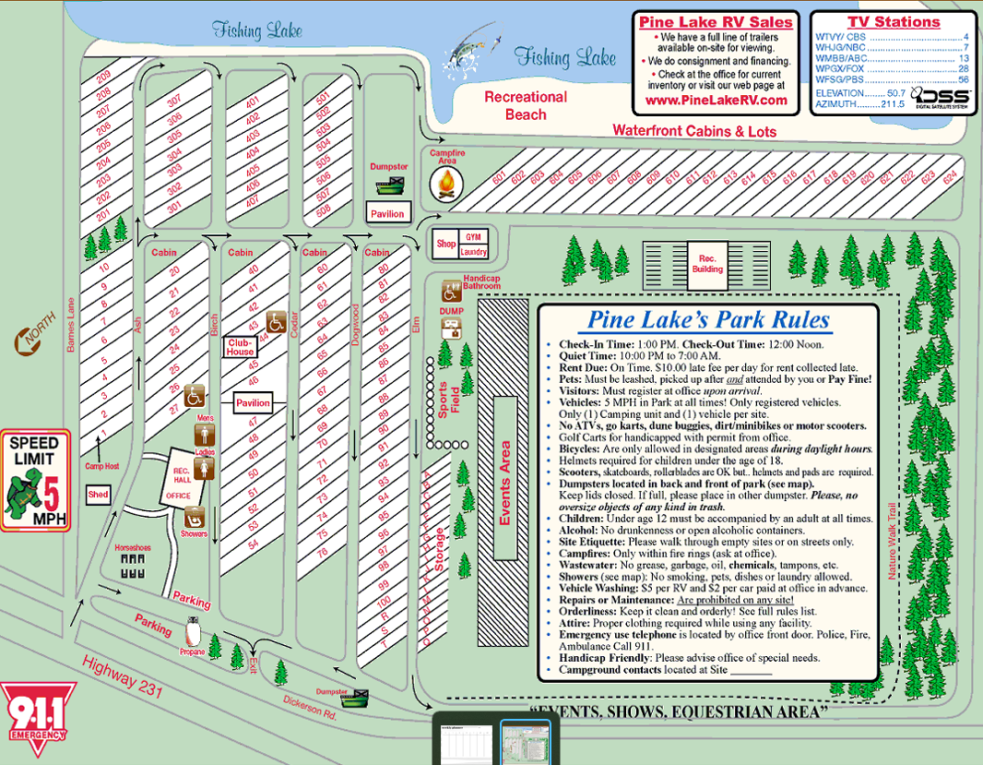
You are assigned site #:

Call if you have any questions. 850-499-2486 or 850-722-1401 Office hours are 8:00 to 11:00 & 1:00 to 5:00 MON through SAT.
We hope you enjoy your stay!
Leave a review on:
https://campgrounds.rvlife.com
for 10% off one night on your next stay.

ELM LANE
DOOGWOOD
CEDAR LANE
BIRCH LANE
ASH LANE
BARNES LANE
Office-

